Christmas Present Catcher

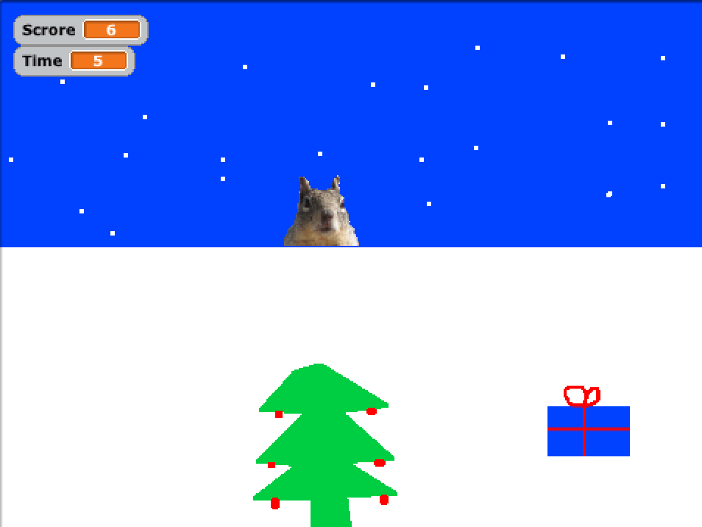

# Sprites

1. Add three new sprites. Draw a Christmas Tree and a Present and add squirrel from the sprite library.
2. Name them Tree, Present and Squirrel

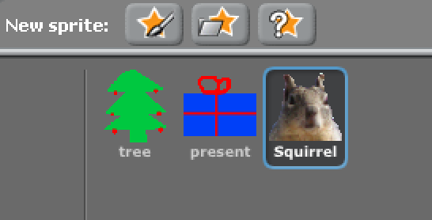

# Background

Select the Stage, select the backgrounds tab and select Paint. Here you can draw a snowy background for the game. Delete the plain white background.

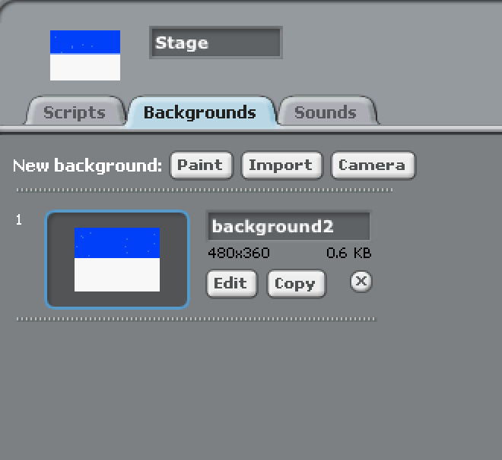

## Variables

Add two variables. One called Time and one called Score

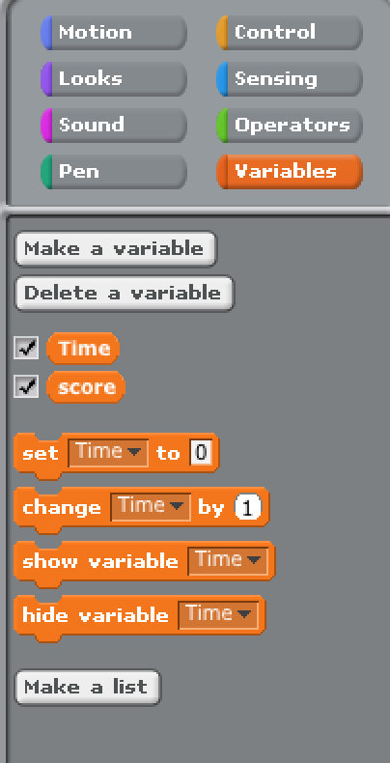

# Scripts

For the present add these scripts

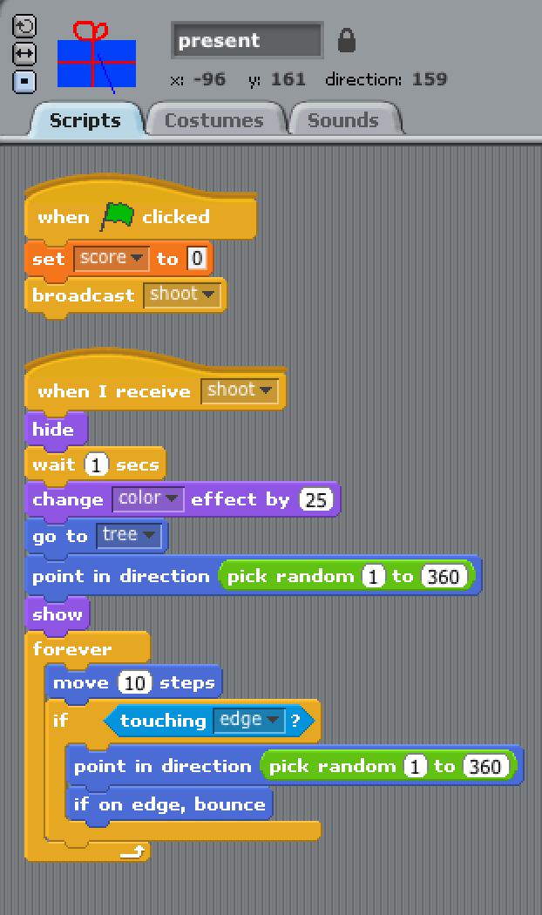

And for the squirrel add these scripts

